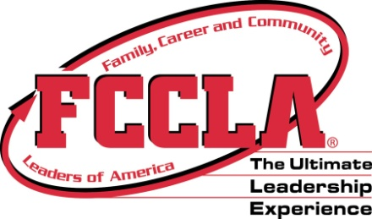
Delaware FCS/FCCLA 2018-19 Dates to Know

302-735-4015 www.delawarefccla.org rita.hovermale@doe.k12.de.us

18-20 State Officer Training

28-2 National FCCLA
Atlanta, Ga

1 State Officer planning
day

12 State Officer Meeting

20-21 ProStart Training
Delaware Tech, Dover

28 Chapter Officer selections
complete

2 FCS Teacher Meeting
Collette, 5:30pm

Beginning planning for
competitive events/conference
9 State Officer Meeting, 5pm

9-10 Fall Leadership
Delaware State University

26 Steps to Leadership
ProStart Conference
DTCC, Dover

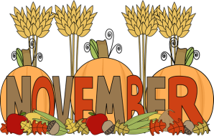

Continue work on
competitive event preparation

29 State Officer Meeting and
Christmas Party, 5pm

Continue work on competitive event preparation

9 State Officer Meeting, 5pm

Continue work on
competitive event preparation

4 State Officer
Application Deadline

12 State Officer Meeting, 5pm

19 Officer Candidate Interviews

26 State Conference
Registration Deadline

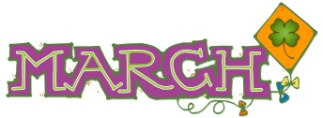
1 ProStart Invitational
Chase Center, Wilmington

26 State Officer Meeting, 5pm

1 Conference Prep, 3pm

2 Leadership Conference
Modern Maturity Center
Dover

3 Leadership Conference
Modern Maturity Center
Dover

17 State Officer Transition
Team Meeting

ProStart PD

TBD State Officer Training

TBD CTSO State Officer
Training
30- July 4
FCCLA Conference
Anaheim, CA

