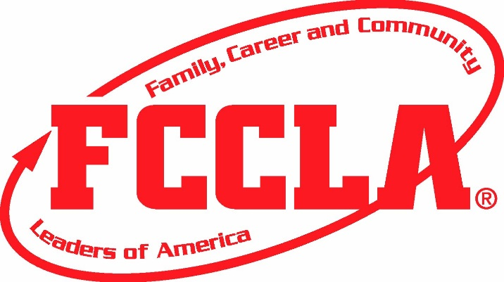 Adviser
Fundraising Ideas
- Serve concessions during athletic/school/community events
- Offer childcare service during the evening or weekends near holidays. Hold it at your local library, and plan age appropriate activities.
- Offer catering services for special events.
- Contact fundraising business (brochure sales). Check fcclainc.org for fundraisers that partner with FCCLA.
- Conduct a Penny War by setting out bottles at lunchtime. Label each bottle for a grade level. Challenge grades to accumulate the most value in their jar. Each penny means plus one point, while anything larger means that much less for the total.
- Put on a banquet for a community group.
- Ask local businesses to match funds you raise through a car wash held in a corner of its parking lot.
- Have a “take over” night at a local restaurant. Customers bring a flyer with them and you will receive a portion of the proceeds.
- Create and sell T-shirts featuring school or class slogans.
- Hold a “handyman day”. Arrange to perform an hour of odd jobs at people’s homes in exchange for donations.
- Paint faces at a community event.
- Hold a hamburger/hot dog/food sales at home athletic events.
- Sell and deliver special greetings-balloons, buttons, carnations, etc. for Valentine’s day, graduation or other special events.
- Sponsor a Mother’s Day meal and encourage families to attend.
- Sponsor a Color Run
- Hold a community yard sale in your school’s parking lot
- Hold a silent auction. Display donated items and attach bid sheets. Give students and staff several days to try to top the last written bid for the item.
- Sell Scratch off cards for a chance to scratch to win a prize
- Sell “the Dinner and Movie” Fundraising Card - offers discounts up to 50% at more than 100,000 different restaurants, theatres and movie rental stores for an entire year.
- Pizza fundraiser cards are a popular fundraiser. You sell the Pizza Fundraising Cards for $10. The card entitles the holder to a free medium one topping pizza when they purchase a large one topping. The cards are good at thousands of locations including specific participating Papa Johns, Pizza Huts and more.

